HONOURING
GARETH RUI A BECKET SHEARMAN

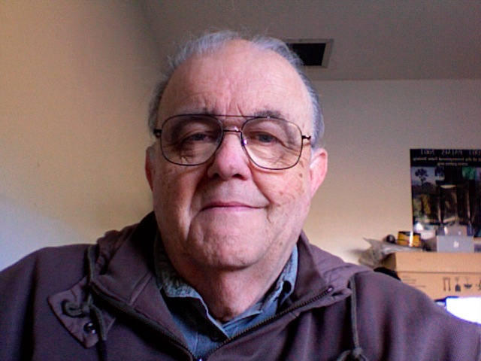

PLEASE JOIN MAE AND OTHERS WHO TREASURED GARY
TO SHARE MEMORIES OVER COFFEE AND COOKIES

VICTORIA PUBLIC LIBRARY
735 BROUGHTON STREET
SUNDAY NOVEMBER 17, 2013
2PM-4PM

RSVP – Sue Hanley (sue.hanley208@gmail.com)

